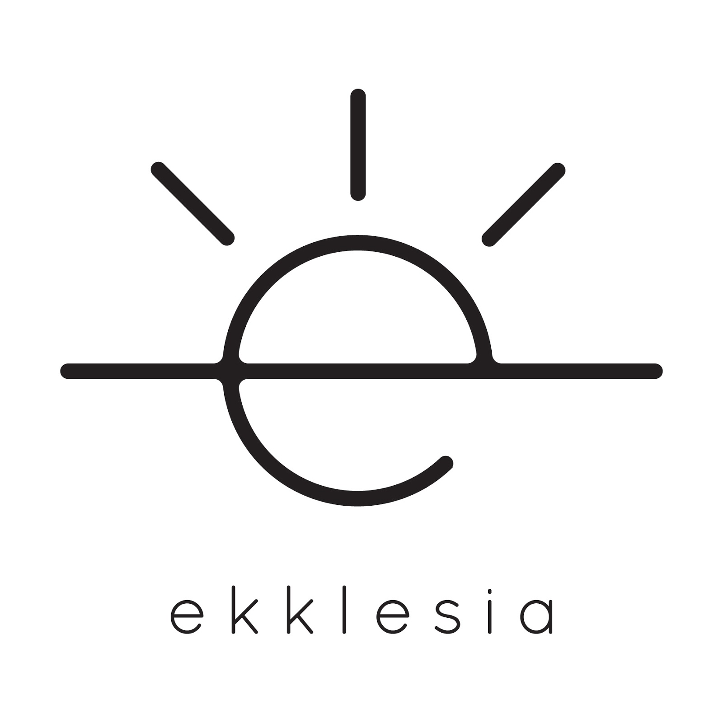

Ekklesia Photographic Non-Release

I do not give Ekklesia Hattiesburg permission to publish in print, electronic, website, or video format the likeness or image of my child.

_________________________________________
Minor’s Name (Please Print)

________________________________________
Parent/Guardian Name (Please Print)

_______________________________________
Parent/Guardian Signature (Please Print)

______________________________________
Date (The release is in effect for 1 year)

